MECH 325

**Team Assignment #1**

Team E4

horizontal line

# 

# Team E4:

Amran Osman

Friend Prakitpong

Gianni Co

Hassan Iqbal

Husein Alatas

Ricky Asfour

Steven McCulloch

## Summary

Table 1: Machine Parameters

|  |  |  |  |  |  |  |
| --- | --- | --- | --- | --- | --- | --- |
| Input Power  From Motor  PM | Power to Screw  PScrew | Gear Train Value  *e* | Efficiency  η | Gel Flow Rate  Q | Overall Cost  C (USD) | Performance Metric  Q/C |
| 212.7 W | 199.9 w | 1 | 94% | 200 ml/s | $39.84 | 4.64 |

Table 2: Bill of Materials

|  |  |  |  |  |
| --- | --- | --- | --- | --- |
| Part # | Part | Supplier | Description | Cost  ($USD) |
| 57655K58 | Driven Gear | McMaster-Carr | 14.5°, 2.25’’ø, 36 tooth nylon gear, 16 TPI | $15.83 |
| 57655K58 | Driving Gear | McMaster-Carr | 14.5°, 2.25’’ø, 36 tooth nylon gear, 16 TPI | $15.83 |
| 98935A715 | Lead Screw | McMaster-Carr | Carbon Steel, ACME, RH, ½’’-8 thread, 0.125’’ per rev, 12’’ long | $6.00 |
| 94815A107 | Nut | McMaster-Carr | Carbon Steel, ACME, RH, ½’’-10 thread, 0.1’’ per rev | $2.68 |

### General Approach

1. **Data collection and preprocessing:**
   1. Pull all the imperial plastic, brass, and steel, spur gears from McMaster-Carr.
   2. Find every permutation of gear pairs that can mesh together. Make a note of the part number, cost, pitch diameter, face width, and the number of teeth of both the driver and driven gears. The gear ratio of the simple gear train was also noted down. Gears are only considered to mesh together if:
      1. Gears are of the same material (e.g. plastic-plastic, steel-steel)
      2. Gears have the same pitch/module
      3. Gears have the same face width
   3. Pull all the right-handed ACME steel lead screws less than 12’’ in length from McMaster-Carr and make a note of the part number, cost, lead, major diameter, and thread for each.
   4. Pull all the right-handed steel hex nuts from McMaster-Carr and make a note of the part number, cost, major diameter, and thread for each.
   5. Find every single permutation of leadscrew and nut pairs and make a note of their total cost. A leadscrew and nut are only considered paired if their threads and major diameters are the same.
   6. Find every single permutation of leadscrew + nut + gear train (LS - N - GT).
2. **Calculation:**
   1. Find an expression relating leadscrew-side torque, leadscrew-side RPM, motor-side torque, motor-side RPM, gear ratio, and motor power to chamber pressure, gel exit velocity, gel flow rate, and reaction force on the leadscrew.
   2. Calculate the values mentioned in *2-a* above for every LG-N-GT assembly using numerical methods. The convergence criteria were chosen such that the operating point of the assembly (in terms of motor-side torque and RPM) fell on the given motor curve:

* 1. Calculate preliminary bending stresses on the gear train and critical buckling load, tensile load, and thread bearing pressure on the power screw.
  2. Set safety factor thresholds (initially 2 for leadscrew and nut, 2 for gear train)
  3. Filter out every LG-N-GT that fails to meet these thresholds.
  4. Perform AGMA (or equivalent) stress calculations on the best performing (flow rate/cost) LG-N-GT assembly’s gear train and recalculate safety factor thresholds for the gear train (as in step *2-d*)
  5. Repeat step *2-e,* and *2-f* as many times as necessary

# 

# 

# Assumptions and Notes

### Assumptions

* Steel on steel friction coefficient between the power screw and nut is 0.17
* Gears run in an environment where the ambient temperature is 20°C
* Gears are initially lubricated with oil, but no maintenance is applied
* The entire gear train is assumed to be 94% efficient (0.983)
* If we select nylon gear, there are negligible differences between types of nylon between manufacturers.

### Additional Notes

* To properly attach the pinion to the motor shaft, a shaft coupling will be required, but this is not within the scope of this project.
* Attaching the gear to the power screw sleeve can be achieved by boring out one gear to have a 3/4” bore diameter. This leaves a sleeve thickness of 0.0625” and another 0.0625” clearance between the screw and the sleeve. See Fig. 1.
* If we had a 10 cm long sleeve, we could directly drive the screw with the motor, but we assumed having a gear train was a requirement.

### 

Fig.1 - Sleeve for lead screw gear

# Results

### Dataset Size Summary

* 79 unique gear ratios
* 1208 unique gear trains
* 114 unique leadscrew-nut pairs
* 137940 unique leadscrew-nut-gear train assemblies

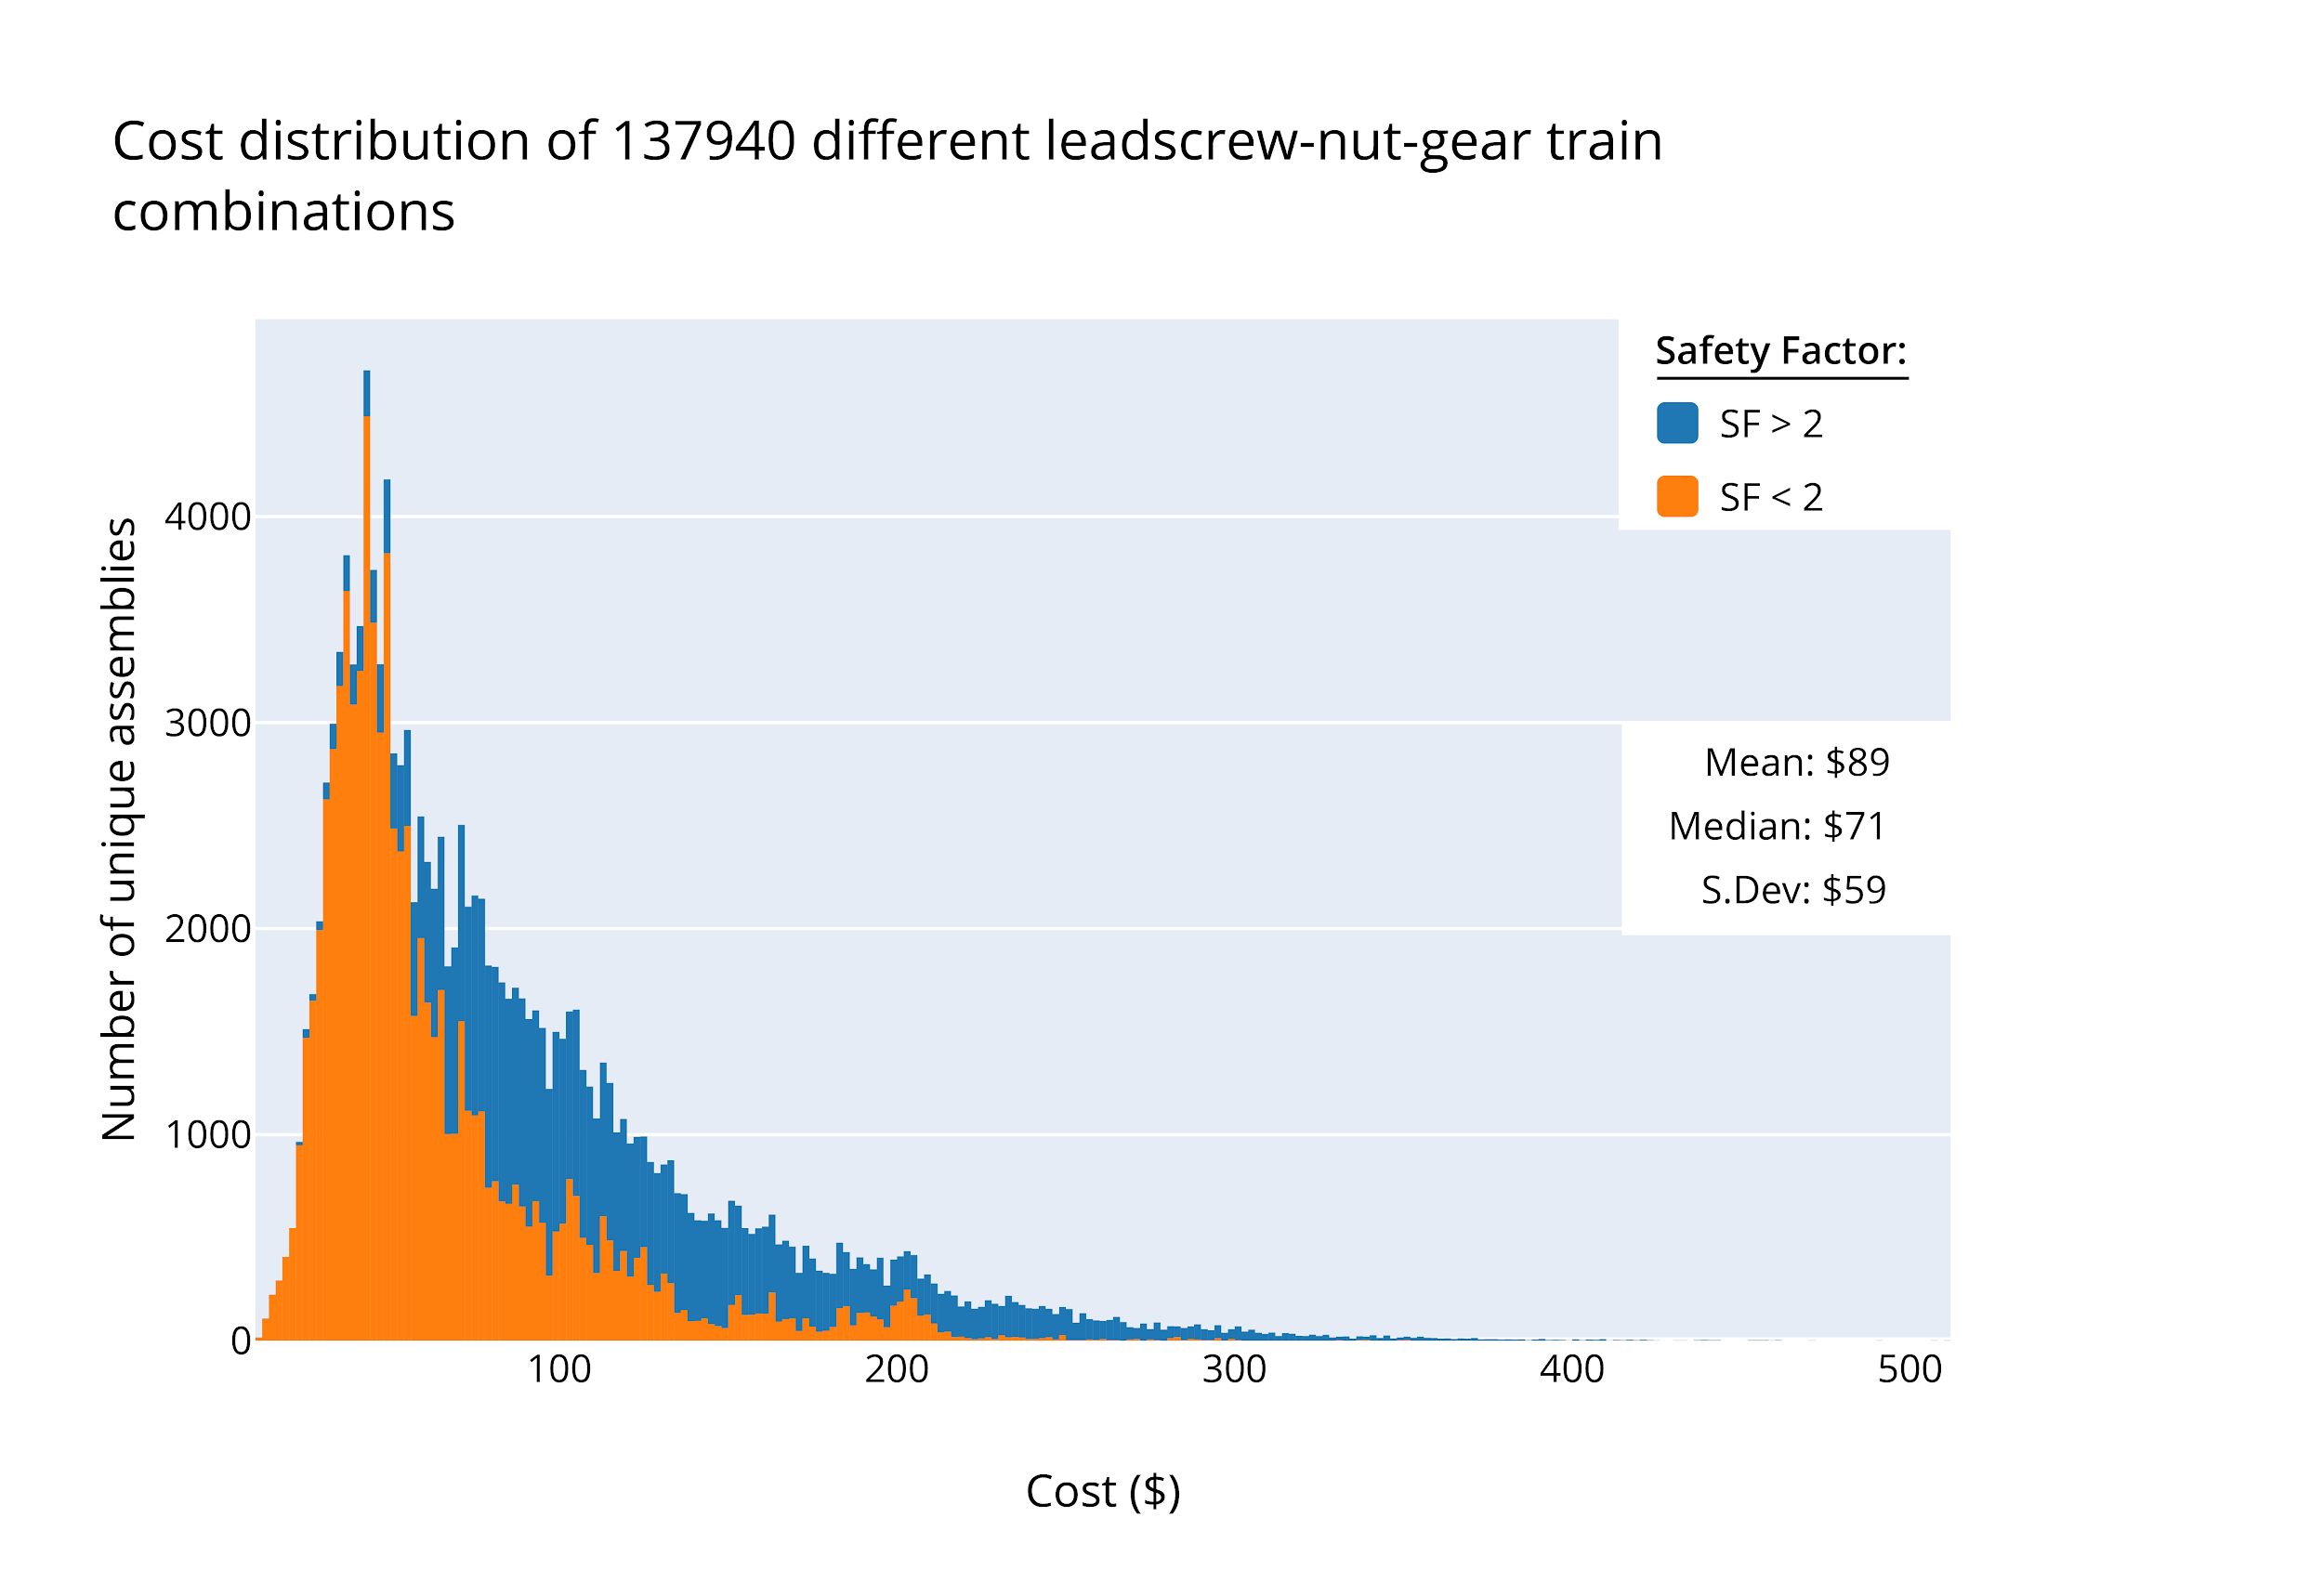

Fig.2 - Cost distribution of all leadscrew-nut-gear train combinations.

### 

## 

## 

## 

## Appendix I - Power Screw Calculations

### Power Input of the Motor

$P_{motor}=\left(482 rpm\right)\left(\frac{2π}{60 }\right)\left(4.518 Nm\right)=228 W$

### Power Input to the Screw

$P_{screw} = P_{motor}*η=228*0.94 =214.36 W$

### Screw Mean Diameter

$d_{m}=d_{major}- \frac{p}{2}$

$d_{m}=1/2in- \frac{1/8in}{2}=0.4375in$

### Screw Minor Diameter

$d_{r} = d_{major}-p = 0.375in$

### Screw Lead Speed

$v= Lead*angular velocity = 0.125 in/rev* 482/60 rev/s$ =1.004 in/s = 2.55 cm/s

### RPM of Power Screw

$N_{screw}=N_{motor} * e = 482* 1=482rpm$ = 50.475 rad/s

### Power Screw Torque

$T_{screw}= P_{screw} / ω_{screw}$ = $4.247 N*m$

### Pressure in the Compression Chamber

$P=v*5kPa/mm/s=18.35mm/s*5=127.5 kPa$

### Force Transmitted to Chamber

$F=P*A=127.5 kPa*π*\left({0.05m}^{2}\right)=1001.4 N$ =225.12 lbf

### Torque to Raise

$T_{r}=\frac{F*d_{m}}{2}*\frac{μ*π*d_{m}*\left(\frac{1}{cos \left(θ\right) }\right)+L}{d_{m}*π-μ*\frac{L}{cos \left(θ\right) }}$ = 1.637 N*m (less than Tscrew)

### Power Required by Power Screw

$H=T*RPM*\frac{2π}{60}=1.637Nm* 50.475 rad/s= 82.62W =0. 111 hp$ <Pmotor

### Volumetric Flow Rate

$\dot{V} = v*A = 2.55 cm/s * π*5^{2}=200.3 ml/s$

### Body Shear Stress

$τ_{yz}= \frac{16 T_{R}}{πd_{r}^{3}}=$ $9.647 MPa =1399 psi$

### Bearing Stress

$σ_{B}=-\frac{2(0.38F)}{πd_{m}n_{t}p} =$ $-995.8 psi$

### Axial Stress

$σ_{y}=-4F/(π{d_{r^{}}}^{2}) = -2038 psi$

### Thread Root Bending Stress

$σ_{b}=σ_{x}=\frac{6(0.38F)}{πd_{r}n_{t}p}=$ $3485 psi$

### Von Mises Stress

$σ^{'}=\frac{1}{\sqrt{2}}[{\left(σ_{x}-σ_{y}\right)}^{2}+{\left(σ_{y}-σ_{z}\right)}^{2}+{\left(σ_{z}-σ_{x}\right)}^{2}+6\left(τ_{xy}^{2}+τ_{yz}^{2}+τ_{zx}^{2}\right)]^{0.5}$ $= I$

$σ^{'}=5410.4 \left( PSI\right)< σ_{Y}(13000 PSI)$

# 

# 

# 

# 

# 

# 

# 

# 

# 

# Appendix II - Gear Bending Stress Calculations

**Predefined Variables**

AGMA does not provide calculation parameters for nylon gears. Alternatively, we’ve found a manufacturer providing a similar method to calculate the allowable bending stress of a nylon gear. We’ve used their values found here (<https://sdp-si.com/plastic/design-of-plastic-gears.php>) in our calculations, with additional values from this datasheet (<https://media.mcam.com/fileadmin/quadrant/documents/QEPP/Global/English/Product_Data_Sheets_GEP/Nylatron_MC901_PDS_GLOB_E_19092016.pdf>). This is acceptable due to the fact that we have already previously calculated for a safety factor, and this is only a confirmation calculation. Due to the website using metric, all values for this calculation has been converted to metric, and only stress will be converted to imperial at the end.

**Bending safety factor for 57655K53:**

**Given:**

### Torque

= 4.247 Nm

### Angular velocity

= 50.475 rad/s

### Pitch diameter

= 0.05715 m

### Face width

= 0.0079375 m

### Teeth count

= 36

### Lead of screw

= 0.00254 m

**Calculated:**

### Tangential force

= transmitted torque / (pitch diameter / 2) = 148.6264 N

### Form factor

= f(teeth count) = 0.553 ul (unitless)

### Module

= pitch diameter / teeth count = 0.0015875 m

### Bending stress, ideal

= tangential force / (form factor * module * face width) = 3093.531 psi

### Daily operating hours

= ((0.1m / (lead of screw * angular velocity / (2pi))) * 40 cycles * 250 days / 365 days) / 3600 s/hr

### Working factor

= f(daily operating hours, light impact) = 0.8

### Speed factor

= f(tangential speed) = 1

### Temperature factor

= f(operating temperature) = 1

### Lubrication factor

= f(lubrication) = 1

### Material factor

= f(plastic vs. plastic) = 0.75

### Bending stress, real

= ideal bending stress * speed factor * temperature factor * lubrication factor * material factor / working factor = 2900.186 psi

### Maximum allowable bending stress

= f(module, number of cycles) = 5 kgf/mm2 = 7111.67 psi

### Stress cycle factor

= f(brinell hardness) = f(180 HB) = 1.5

### Reliability factor

= f(reliability) = f(0.999) = 1.25

### Fully corrected bending strength

= 8534.006 psi

### Safety factor of Bending

= fully corrected bending strength / bending stress = 2.45

## 

## 

## 

## 

## 

## 

## 

## 

## 

## 

## 

## Appendix III - Final Calculations

### Predefined Variables

$H=Power \left(watts\right)=$ 228 W

$n_{p}=Driving gear velocity (rpm)$ = 482 rpm

$g=Gear efficiency=94\%$

$L=Lead=$ 0.125’’

$N_{gear}=Number of teeth on gear=$ 36

$N_{pinion}=Number of teeth on pinion=$ 36

### 1. Gear Ratio and Gear Velocity

$e_{actual}=\frac{Npinion}{Ngear}=$ 1

$n_{g}=e_{actual}*n_{p}=$ 482 rpm

### 2. RPM speed and Torque at Screw

${RPM}_{screw}=e_{actual}*n_{p}=482 rpm$

$T_{screw}=\frac{T_{motor}}{e_{actual}}*η=$ 4.247 Nm

### 3. Power Transmitted and Lead Speed of Screw

$P_{screw}=T_{screw}*RPM_{screw}*\frac{2*π}{60}$

= 214.36 W

$v_{screw}=L*\frac{T_{screw}}{60}=$ 1.004 in/s

### 4. Pressure and Force on Chamber

$P_{chamber}=5*1,000,000*v_{screw}=1.004in/s*5*1x{10}^{6}=127.5 kPa$

$F_{chamber}=P_{chamber}*{Area}_{chamber}=$ $343.77 kPa*π*\left({0.05m}^{2}\right)=225.12 lb$

### 5. Output Flow

$\dot{V}=v_{screw}*{Area}_{chamber}=$ 200.3 mL/s

### 6. Final performance rating

$PR=\dot{\frac{\dot{V}}{{cost}_{power screw}+{cost}_{nut}+{cost}_{gear}+{cost}_{pinion}}=} 4.64 mL/s\$$